QUALIFICATION TEST PROCEDURE

FOR THE

MULTI-OIL LEVEL INDICATOR
AUTOMATION OF THE OLS TEST BENCH

ALLEN AIRCRAFT PRODUCTS, INC.

REPORT #250129

PREPARED BY: Rick Ales, Consultant, R. Ales Consulting LLC
Name, Title

APPROVED BY:
Name, Title

ALLEN AIRCRAFT PRODUCTS, INC.

RAVENNA, OHIO

Revision History
Rev | Notes | By | Date
Draft 1 | Initial Draft | R. Ales | 2025/03/18
Draft 4 | Update to reflect Pre & Post Pot test requirement changes | R. Ales | 2026/07/08

Table Of Contents
1.0 Purpose of Test Procedure 4
1.1 Reference Documents: 4
1.2 Notation 4
2.0 Test Plan 4
2.1 Requirements Cross Reference Summaries 4
2.2 Test 5
2.3 Analysis 5
2.4 Inspection 5
2.5 Test Results Record 5
3.0 Description of Test Item 5
3.1 General Test Data Requirements 5
3.2 Criteria for Retest 6
4.0 Test Approach 6
4.1 Test Conditions 6
4.2 Measurement Tolerances 6
4.3 Test Fluids 6
4.4 Test Setups/Equipment 6
4.5 Test Procedure Revisions 7
4.6 Allen Aircraft Contacts: 7
5.0 QTP Testing 7
5.1 Functional Requirements Test Procedures 7
5.1.1 Test Initialization 7
5.1.2 Hardware Inputs: 10
5.1.3 Hardware Outputs: 11
5.1.4 HMI: 12
5.1.5 Document management 14
5.1.6 Enter the test bench configuration parameters into XL test plan. 15
5.1.7 Enter DUT specific configuration parameters into XL test plan. 15
5.1.8 Calibration Procedure 16
5.1.9 Troubleshooting Aids 17
5.1.10 Use Case 3: Read Test Configuration -- Production Test User 18
5.1.11 Load DUT identification information 20
5.1.12 Load DUT into the test bench. 21
5.1.13 Use Case 5: Run DUT Test -- Production Test User 21
5.1.14 Use Case 5: Generate DUT Test Report -- Production Test User 26
5.2 Non - Functional Requirements Test Procedures 28
5.2.1 Level Calibration Repeatability & Accuracy 28
5.2.2 Resistance Calibration Repeatability & Accuracy 28
5.2.3 Measurement Gage R & R 28
5.2.4 Stability and Drift 28
Appendix I. Hardware Installation 28
Appendix II. Instrument Initialization 28
Appendix III. LabVIEW Application Installation 28

- Purpose of Test Procedure
The purpose of the Qualification Testing Procedure is to demonstrate how the Allen Aircraft Automated Oil Level Sensor Test Bench, aka Multi-Level Oil Indicator (MLOI) shall perform within the requirements of Technical Requirements for the Multi-Level Oil Indicator Automated OLS Test Bench, Report #250129 (ReqSpec).
  - Reference Documents:
ACCEPTANCE TEST PROCEDURE FOR ALLEN 8005571.05, Report# 200333
  - Notation
- Means Informative
- Means Test Case traceable to a Requirement
LV LabVIEW
VI Virtual Instrument, a top-level LabVIEW app or a sub processing block
AAP Allen Aircraft Products
QUAM AAP AS9100 Quality Manual
ATP Acceptance Test Procedure
OLS Oil Level Sensor
CIP Custom Interface PCB
DUT Device Under Test
AI Analog Input
XL MS Excel
MLOI Multi-Level Oil Indicator, designation of the automated tester described herein.
Epic 1 Single DUT automated test capability
Epic 2 MLOI capability extended to accommodate other OLS product lines.
Epic 3+ Uses the Custom Interface PCB (CIP). Also, the MLOI capability may extended to accommodate multiple sensors DUT tested simultaneously (TBD)
HW 1 Prototype phase where all items are COTS and custom configurations are achieved through breadboards or otherwise temporary connections.
HW 2 Production where custom interfaces have been designed and fit for purpose implemented, ie interface unit manufactured as a custom PCB.
<parm> Indicate the tester should supply the indicated parameter as appropriate.
- Test Plan
  - Requirements Cross Reference Summaries
Test cases and procedures are traceable to the requirements of the ReqSpec by being numbered with the corresponding requirement number.
Upon successful execution of this QTP, the MLOI Automated OLS Test shall be deemed suitable for ATP and production testing of the approved corresponding OLS product. The initial test shall cover EPIC 1 as defined in the ReqSpec for Elevate OLS sensor (PN 8005571.05).
  - Test
Verification that a requirement is met is by a thorough exercising of the item. This includes actual measurement of unit performance with calculations/analysis as required under controlled and/or recorded environment and in accordance with approved test procedures.
  - Analysis
The requirement is substantiated by Analysis. Analysis is the processing of accumulated results and conclusions to determine whether a requirement has been verified. The analytical results may be based on original study, or derived from lower-level examination, test, demonstration, or a formal analysis.
  - Inspection
Inspection is a visual examination, physical manipulation, weighing and/or measurements to verify that the hardware item conforms to the design requirements and includes review of documentation controlling configuration and requirements.

  - Test Results Record

The test cases shall provide space to record the results of that test case and an overall PASS/FAIL score shall be recorded. This will serve as the Test Results Record when completed and signed off by the designated stakeholders.

- Description of Test Item
The Allen MLOI Automated OLS Test Bench is illustrated in Appendix II. The MLOI is an LabVIEW automated system intended to be a hands-free product test bench that minimizes human product evaluation by controlling the pump and data acquisition system used to precisely control the test tank oil level to a specified Test Point and measure and record the OLS response then determine if the Device Under Test response complies to the designated product ATP specification and report a PASS/FAIL status for that product at the completion of the test.
  - General Test Data Requirements
One MLOI Automated OLS test bench designed to comply with EPIC 1 of the ReqSpec, shall be evaluated. One or more designated and characterized OLS product will be used as DUT to evaluate the performance of the MLOI under test.
Data for each test shall be recorded on individual data sheets. Each sheet shall contain as a minimum the following:
- Test Title: “QTP Results for MLOI Automated OLS Test Bench, EPIC 1”
- Date of test
- Test procedure paragraph reference
- All pertinent environmental conditions
- Type of fluid used and temperature (if applicable)
- Name and signature of test operator(s)
- Equipment, instruments, tolerances, and calibration
- Input, output, and computed data
In addition, photographs of the test unit before and after testing, and of the test setup prior to testing must be taken and provided in the Test Report. Photographs shall be available for customer review prior to testing, if required.
Supporting data, such as a test log, a narrative history of the test and a data acquisition recording of the required test parameters (input and output), if applicable, per the test procedure, shall be made available for customer review.
  - Criteria for Retest
In the event of a test failure, the test shall be suspended and the cognizant <customer> representative shall be notified within 24 hours of the finding. The nature and amount of any redesign and retest shall be coordinated with and approved by <customer> prior to resumption of the test program.
- Test Approach
Unless otherwise specified, the following general requirements shall apply to all Section 5 procedures.
  - Test Conditions
Unless otherwise specified, the tests shall be conducted at ambient temperatures between +70°F and +80°F and at local laboratory ambient pressure and humidity conditions up to 90% relative humidity. The ambient conditions at time of testing shall be provided on the test data sheet, as noted in Section 3.1.
  - Measurement Tolerances
The maximum allowable tolerance on test condition measurements shall be as follows:
- Pressure: ± 2%
- Temperature: ± 2°F
- Flow: ± 2%
Other tolerances shall be as specified in the detailed procedure
  - Test Fluids
The MLOI test tank will use oil conforming to <test fuel spec (common name)>. The fluids for each test shall be recorded on all data sheets.
  - Test Setups/Equipment
Test setups are defined under the applicable sub-paragraphs of Section 5.1 herein. The Qualification Test Report shall include a complete equipment list identifying each specific instrument used for each test along with its corresponding range and accuracy.
Note: The setups illustrated are a guide. Equivalent instrument substitutes may be used as long as the measurement accuracy of the test parameter is not compromised.
  - Test Procedure Revisions
All test procedure revisions required during test – other than typographical errors that do not change the technical intent of the test - shall be approved in writing by the responsible AR at a minimum and included in the test report. These revisions include, but are not limited to, revisions where the initial stated objective of the procedure or method is not altered, and the means of achieving those stated goals are not altered.
  - Allen Aircraft Contacts:
The following list of Allen Aircraft personnel, unless otherwise noted, are responsible for the Design Testing and Quality verification of the product under test:
<name>, Project Design Engineer, email:
<name>, Test Engineer, email:
<name>, Director of Quality Assurance, email:

- QTP Testing
Functional testing is based on an analysis of ReqSpec. Each Requirement of the ReqSpec shall be tested on a PASS/FAIL basis by the procedures described by test cases of Section 5.1, numbered corresponding to the functional Requirement being tested.
Performance testing includes but is not limited to activities such as Calibration and Gage R&R, which will be described in Section 5.2 and may deviate from the functional requirement numbering system.
  - Functional Requirements Test Procedures
The following test cases describe the test procedures to be used to verify the functional requirement and the success (PASS/FAIL) criteria. The tester should mark the check box if they concur; the test case passed if all check boxes are marked then the test should circle PASS otherwise circle FAIL.

Preform the following steps to load the LabVIEW application (LV), which applies to nearly all the test cases, to conduct the test procedures that follow.

Test Initialization
- Have AAP IT department install LabVIEW (LV) Runtime on the Target Test System.
- If testing the development environment, have AAP IT department install LabVIEW Professional Development System on the Target Test System.
- Load the current version of the LV MLOI application as shown in Appendix III.
NOTE: At this point, MLOI app functionality can be exercised in simulated mode without hardware or instruments installed, If so, skip to Test Case 1).
- Configure the system hardware as shown in Appendix I.
- Initialize the instruments and motor controller as shown in Appendix II

- Verify both the LV application code and HW are version controlled.
- Login to your favorite internet browser and navigate to https://github.com/AllenAircraft/PWC-OLS/tree/main. Contact AAP IT department for login information.
- On the code page, verify that the code under “Main” branch is populated and Release Notes are update.
- Under “Releases” to the right of the code block, verify the “Latest” release revision number corresponds to engineering documentation.
- Verify the hardware drawings, including block diagram, schematic, assembly drawing and Gerber files are released.
- All hardware files are in the release folder at <Path file>

Tester __________________ Date ______________ PASS FAIL

- The system shall have distinct modes, Production and Developer.
Operation | Production | Development
- Environment | Run-Time | Developer
- Mode | User | Maintenance or User
- Method | Test | Simulate or Test

- MLOI can operate in one of two environments:
  - Run-time – using the LabVIEW Runtime Engine intended for use by the test operator (tester) to execute the MLOI LabVIEW Application during production.
  - Developer – using LabVIEW Professional Development System where debugging is available and is intended for use by Programmer or Test Engineer for maintenance of the MLOI Program. In Developer environment, the user can select between User Mode and Maintenance Mode.
- MLOI has two Modes:
  - User Mode – displays limited set of front panel controls, available by production test operator selection, optional in the developer environment.
  - Maintenance Mode – displays full set of front panel controls available by operator selection in developer environment but not available in Runtime environment.
- MLOI has two Methods of operation:
  - Test –Product test using actual OLS Resistor data sourced from the DataQ and Level data sourced from the Laser, using the full functionality and performance of the complete system.
  - Simulate – Uses simulated DataQ, Laser and Motor Control data based on the ATP test table to evaluate the LabVIEW functional portion of the MLOI Test System. Simulate only tests the accuracy of the LabVIEW Software. Simulate is available only in the Developer environment and in the Runtime environment by password enabled configuration.

- If testing only the LabVIEW application function of the User Mode in Production operation using the Simulate method, run ..builds\MLOI_Elevate\MLOI_Elevate.exe then proceed to section 5.1.4 Production HMI.
- If testing only the LabVIEW application function in Development operation using the Simulate method, then proceed to section 5.1.5 Development HMI.
- If Testing with the full instrumentation environment then, Load Developer environment. Navigate to ..\PWC-OLS\ and double click on _MLOI_Main.vi,
- Verify the Mode dropdown with choice of User and Maintenance is available. (Note other options may be present.)
- Select the Maintenance from the Mode dropdown, run the application.
- Verify the Motor controller panel containing Jog button is available.

- The EPIC 1 System MAY be placed into production service with the HW1 (breadboard) hardware.
- Inspect the Interface Cabinet, check for loose wires, all components are reasonably secure, and strain reliefs are present on all wires that are regularly handled.
Type (circle one) Prototype PCB

- The Interface board is properly installed.

Tester __________________ Date ______________ PASS FAIL

- Hardware status shall be indicated as Green = Good to test; Red = Bad or Fault; Yellow = Needs attention or not automatic, i.e. in simulation mode.
- Power on the instrument power and the motor power supplies. Verify the DataQ, Motor controller and Laser USB port are connected to the USB Hub and the USB Hub is connected to the Workstation USB port. See the hardware configuration procedure in Appendix II.
- On the workstation, right-click the start bar and select Device Manager. Verify that each of the units is recognized by the Device Manager. If not see the installation procedure in Appendix II.
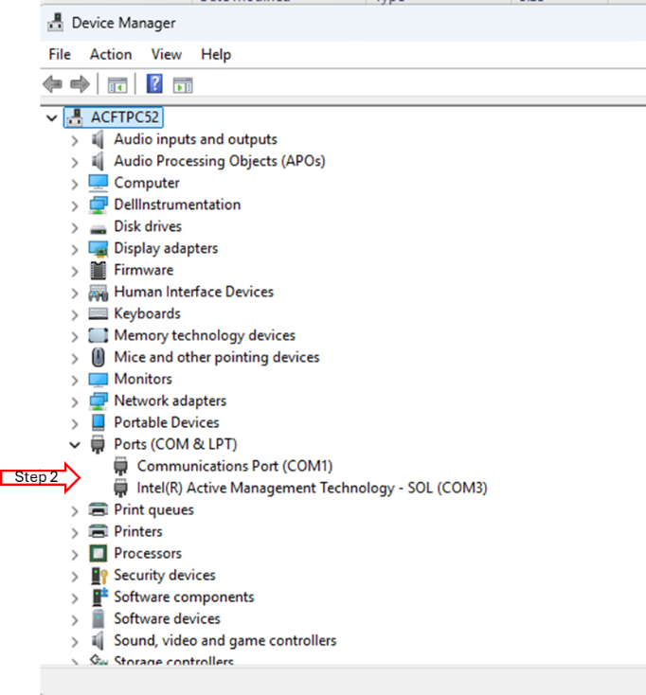
- Verify that the three devices are shown in the Device Manager as shown above.
- Open the LV app if the LV app is not running, click the run button.
- Verify all three status lights are GREEN.
- Disconnect the USB hub from the Workstation.
- Verify all three status lights are YELLOW.
- Turn OFF the simulated mode by pressing the SIM button
- Verify all three status lights are RED.

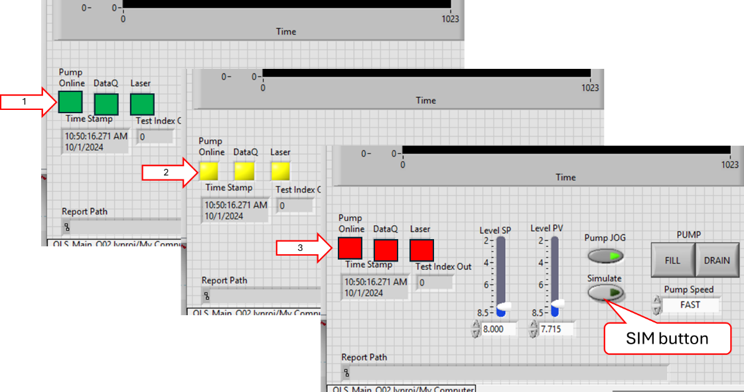

Tester __________________ Date ______________ PASS FAIL

Hardware Inputs:
- ChA and ChB resistance measurement 0-1700Ω +/- 1%
Equipment required:
Volt/ohm meter (VOM);
100Ω and 1KΩ 0.05% Reference Resistors.
- If the resistance calibration is not up to date, then perform a Resistance calibration. See Section 5.2.2, then Run the MLOI App.
- Using the VOM, measure and record the Ref value of the 100Ω reference resistor in ohms.
- Connect the 100Ω resistor to the front panel and record the reading for each Channel.
- Using the VOM, measure and record the Ref value of the 1000Ω reference resistor in ohms.
- Connect the 1000Ω resistor to the front panel and record the reading for each Channel.
- Calculate and record the error for the 100Ω and 1kΩ resistors as:

$$Error = {\left.\left( \frac{Ref-Test}{Ref}\right.\right) x 100}^{}$$

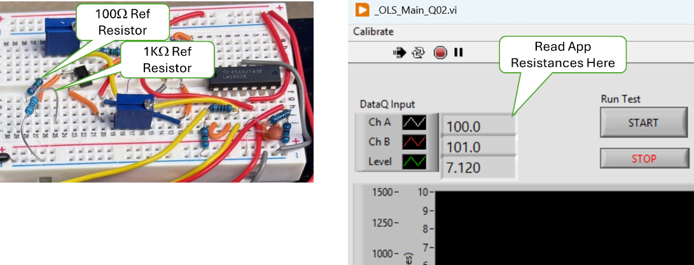
Reference Resistors and Measurement Readout.

Results
Ch | 100Ω | 100Ω Error | 1kΩ | 1kΩ Error
REF
CHA
CHB

- Both the 100Ω and 1KΩ Error for ChA is less than 1.0%.
- Both the 100Ω and 1KΩ Error for ChB is less than 1.0%.
- Both ChA and ChB read 1.7KΩ or more for the 2KΩ resistor.

Tester __________________ Date ______________ PASS FAIL

- ChA and ChB Current Source 14.7 mA +/- 0.05%
Equipment required:
Ammeter (AM);
100Ω and 1KΩ reference resistors.

- Set the AM to the 100mA range and ensure that the probes are set to read current.
- Connect the AM + (pos) lead to the ChA Orange lead and connect he AM – (neg) lead to the + side of the 100Ω reference resistor, ensure the other end of the reference resistor is connected to ground.
- Record the current reading the current. ___________________ mA
- Connect the AM + (pos) lead to the ChA Red lead and connect he AM – (neg) lead to the + side of the 1kΩ reference resistor, ensure the other end of the reference resistor is connected to ground.
- Record the current reading the current. ___________________ mA

- The current reading (X) for ChA was 14.693 <= X <= 14.707 mA
- The current reading (X) for ChB was 14.693 <= X <= 14.707 mA

Tester __________________ Date ______________ PASS FAIL

- Resistance measurement calibration check shall be enforced monthly. Currently not implemented.
- In the Win11 search bar type “RegEdit” and start the Registry Editor.
- In the folder tree in the left pane navigate to:
Computer\HKEY_CURRENT_USER\Allen AirCraft\Elevate OLS Test
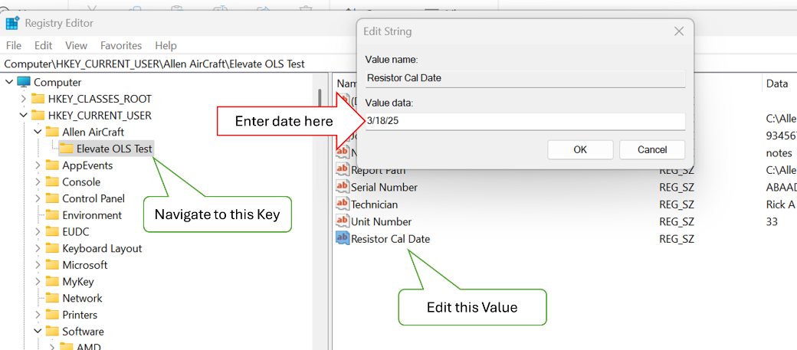
- Open the Elevate OLS Test Key folder, then click on Resistor Cal Date, Edit.
- In the Edit popup add today’s date + 30 days. Start the MLOI application.
- Verify there was no prompt to perform a resistor calibration.
- Stop the MLOI application
- Edit the Resistor Cal Date registry key to be today’s date + 31 days. Start the MLOI application
- Verify the user was prompted to perform a resistor calibration.
- Stop the MLOI application.

Tester __________________ Date ______________ PASS FAIL

- Level measurement (Process Variable PV) 2.5 to 8.5 inches +/- 0.0005”
- Run the Level Accuracy and Repeatability evaluation defined in Section 5.2.1.
- Level accuracy was successfully demonstrated during the Accuracy and Repeatability evaluation of Section 5.2.1.

Tester __________________ Date ______________ PASS FAIL

Hardware Outputs:
- Level control (Set Point SP) 2.5 to 8.5 inches +/- 0.002”
- Run the Level Accuracy and Repeatability evaluation defined in Section 5.2.1.
- Level accuracy was successfully demonstrated during the Accuracy and Repeatability evaluation of Section 5.2.1.

Tester __________________ Date ______________ PASS FAIL
Production HMI:
NOTE: These HMI tests of software requirements may be evaluated in either test (with instrumentation) or simulated (without instrumentation) methods. The following tests may be evaluated in SIM mode except as noted.

NOTE: The Main Indicators and controls are shown below. Each control and indicator has a tool tip available with right click.

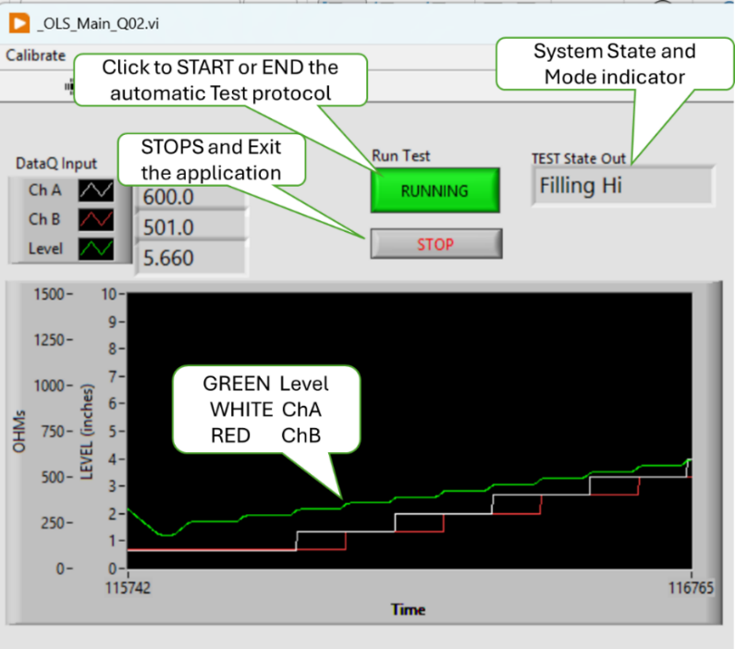
- Shall provide a means to check and set the Level Zero point daily.
- Verify the Zero Prompt occurs after Test Info Dialog is dismissed.
- Note the value of Level_Zero_Gage value in the $ConfigFile. (-2.000 default)
- If Zero Prompt is not displayed on starting MLOI Program, then in windows start, type Regedit. Navigate to Computer\HKEY_CURRENT_USER\Allen AirCraft\MLOI-Elevate and select Level Zero Date, Click Edit>Modify set Value Data to a date prior to today(). Click OK
- Start the MLOI Program. At the test info dialog, click OK, the Zero Dialog should appear saying looking for laser. The laser is found, go to Step 2
- At Error message 534288 click OK. On Laser Not Found, Click on TEST.
- Goto Step 3

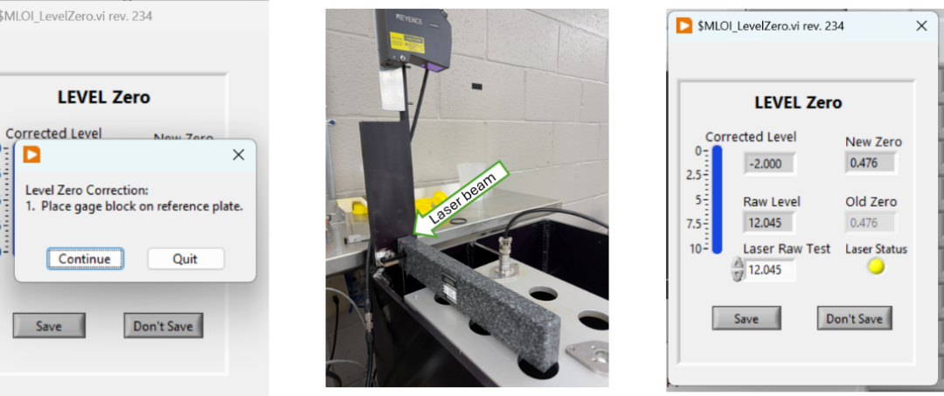
- If in Simulate Method
- Verify that the Laser Status is yellow.
- Verify changing Laser Raw Test input is reflected in Raw Level and New Zero values.
- Note the New Zero value and Click Save
- Restart by clicking on Calibrate>Level Zero and verify the Old Zero value is the New Zero value noted above.

- If in Test Method (Laser is on-line)
- Verify that the Laser Status is Green.
- Verify Laser Raw Test input is hidden.
- Insert a laser target, then note the New Zero value and Click Save see paragraph 5.2.2 Daily Level Zero Correction Check
- Restart by clicking on Calibrate>Level Zero and verify the Old Zero value is the New Zero value noted above.
- Remove the laser target.

- Verify test when Laser is Found.
- Verify the user is prompted to place the gage block on the datum reference plane.
- With the gage block as shown, Note the New Zero then Click on Save.
- Press STOP to end the MLOI Program.
- Press STOP to end the MLOI Program.

- Verify that the Level Zero is persistent.
- Start MLOI, verify that the Level Zero prompt is NOT displayed after the Test Info is dismissed.
- Press STOP to end the MLOI Program.
- Reset Level Zero Date in the registry, restart MLOI and verify that the Zero value noted above is now displayed in Old Zero.

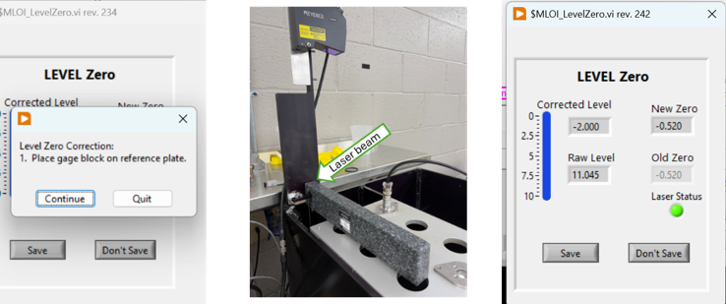

Tester __________________ Date ______________ PASS FAIL

- Level measurement zero calibration check shall be enforced daily
- In the Win11 search bar type “RegEdit” and start the Registry Editor.
- In the folder tree in the left pane navigate to:
- Computer\HKEY_CURRENT_USER\Allen AirCraft\Elevate OLS Test
- Open the Elevate OLS Test Key folder, then click on Level Cal Date,
- On the menu click Edit>Modify.
- In the Edit popup enter the test date.

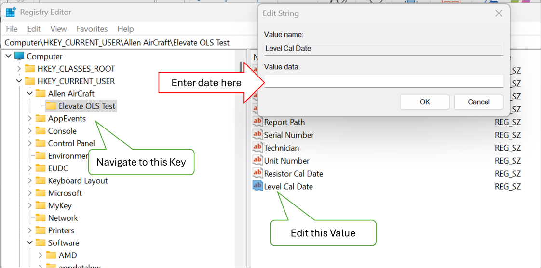
- With the Registry’s Level Cal Date Set to Today.
- Perform Step 2 with entering today’s date.
- Editor Start the MLOI application, Click OK
- Verify there was no prompt to perform a Level calibration.
- Stop the MLOI application
- With the Registry’s Level Cal Date Set to any date but today’s date.
- Perform Step 2 with entering test today date.
- Editor Start the MLOI application, Click OK
- Verify the user was prompted to perform a resistor calibration.
- Repeat Step 4 for four other random dates.

Tester __________________ Date ______________ PASS FAIL

- Shall provide a means to check correct application version is used with the selected Configuration File.
- Start builds ..\builds\MLOI_Elevate\MLOI_Elevate.exe, click OK.
- On the menu select View>Files & Paths.
- Note the ConfigFile.xlsx file name then open the configured $ConfigFile.
- Edit LabVIEW Version (Cell B50) to be some version number ie 0.11.22.33
- If necessary, unblock the file as follows:
- Close the Office file.
- In File Explorer, right-click the file.
- Select Properties.
- On the General tab, look for Security.
- Check Unblock.
- Save the ConfigFile.xlmx by clicking on the X then Yes, Yes to write the ConfigFile.csv which is what the program uses.
- Close MLOI by clicking STOP.
- Check that Version mismatch warning is displayed.
- Start MLOI_Elevate click OK
- Verify that Version mismatch warning is displayed with Expected Version is the value entered above ie 00.11.22.33 and Found Version is the Version of the MLOI app,
- Click Stop, Verify the app closes.
- Start MLOI_Elevate click OK
- Verify that Version mismatch warning is displayed with Expected Version is the value entered above ie 00.11.22.33 and Found Version is the Version of the MLOI app.
- Note the Found Version number returned.
- Click Continue, verify that program continues
- Check that Version mismatch warning is NOT displayed when the configured version matches the application version number.
- Edit the calibration file, set LabVIEW Version (Cell B50) to be the version number noted above.
- Save the configuration file.
- Start MLOI_Elevate click OK
- Verify that Version mismatch warning is NOT displayed.

Tester __________________ Date ______________ PASS FAIL

- Shall provide a means to enter persistent test information.
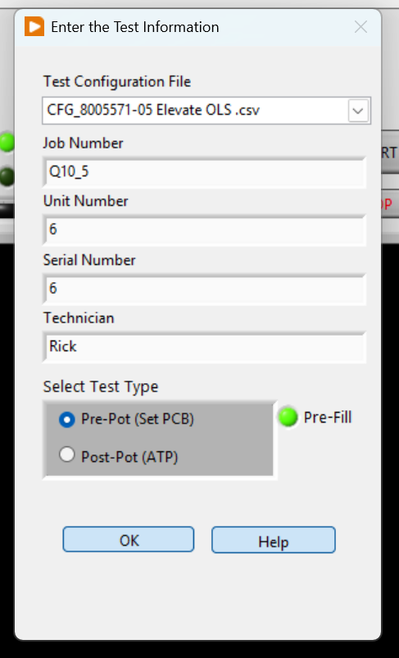
For this section, refer to the figure on the right:
- Click on the MLOI Desktop icon and run the application.
- Verify the application open, in MANUAL mode and Test Information dialog is open.

- Evaluate Test Configuration File dropdown.
- Click on the dropdown then verify a choice of at least one product test configuration file is presented.
- Click on each of the file name then verify each is selected indicated by a check mark and presented in the test box when the dropdown is closed.
- Click OK then STOP to Quit the MLOI Program, restart the program and verify that the selected test configuration file entered above persists in the Configuration File dropdown.
- Repeat Step 2 for each available configuration file.

- Evaluate Test Information.
- Start the MLOI Program, On the Test Information dialog, enter some random test in each of the Job Number, Unit Number, Serial Number, Technician and Notes Fields. Click OK
- CANCEL, STOP to Quit the MLOI Program
- Restart the MLOI Program and Verify that information entered above persists.

- Evaluate Pre-Fill Lube disable.
- With the “PreFill” light lighted GREEN, Click OK
- Verify the Program starts and “Pre-Fill is indicated in the TEST State Out box.
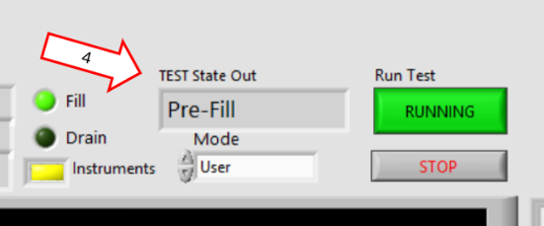

- Stop and restart MLOI.
- Click on the “PreFill” light to turn is OFF (dark), Click OK
- Verify the Program starts, the pre-lube operation is skipped, and “Filling” is indicated in the TEST State Out box.

- Evaluate Help
- Click on the Help button, verify that the instruction PDF launches.
- Evaluate Test Options
- Start the MLOI Program,
- In the Select Test Type box, Select the Pre-Pot radio button. Press OK
- Verify the system starts in manual mode and the Level Controller is displayed.
- Verify that moving the Set Point indicator (Level SP) causes the system Process Variable (Level PV) to respond in kind for various levels.
- Click the START button, verify that the automatic test runs.
- Press STOP, No Quit to exit MLOI Program after each observation.
- Repeat, verify that the Pre-Pot Test remains selected.
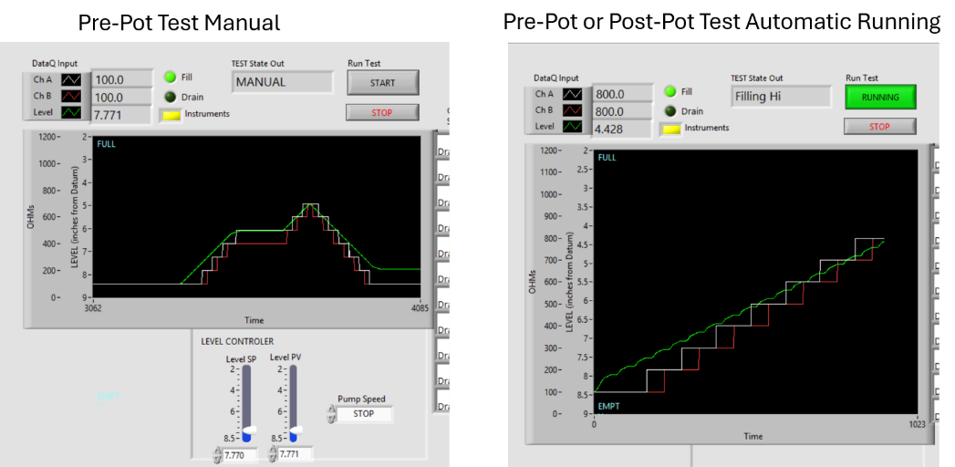

- Start the MLOI Program,
- In the Select Test Type box, Select the Post-Pot radio button. Press OK
- Verify that the program starts in automatic Running.
- Press STOP, No Quit to exit MLOI Program after each observation.
- Repeat, verify that the Post-Pot Test remains selected.

Tester __________________ Date ______________ PASS FAIL

- Shall have a means to assist the operator in setting the sensor PCB depth.
- Evaluate the Set Depth out calculated in the Report File.
- Start the MLOI Program,
- In the Select Test Type box, Select the Pre-Pot radio button.
- Turn off Pre-Fill, Press OK
- Note the Report File name generated from the contents of the Test Name textbox and its path found from the main menu select View>Files & Paths, under Report Path,
- When the test is completed, open the Report File At completion of the test, Open the report file noted above and select the Analysis Sheet.
- At the top of the sheet verify the recommended Set Depth generated from the Optimized PCB Setting graph of the level switch point deviation.
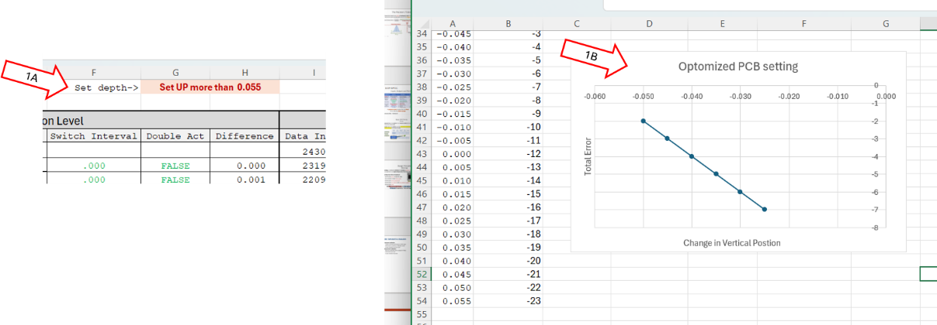

Tester __________________ Date ______________ PASS FAIL

- Shall provide help for each control and indicator.
- Evaluate that each control or indicator has a “tool tip” displayed when mousing over the item or right clicked and “Description & Tip” is selected.
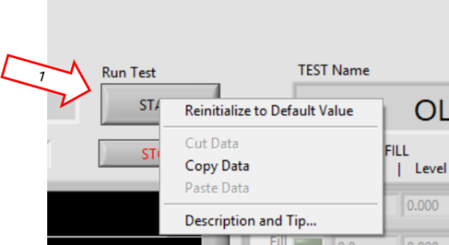
- Right Click on the Run Test button, select “Description & Tip,” verify the appropriate tool tip is displayed.

- Hover the mouse over the Run Test button, verify the short tool tip is displayed.
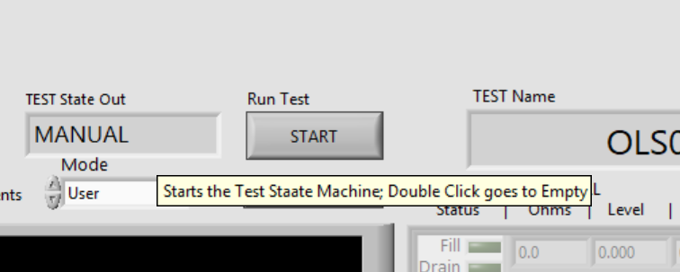

- Repeat for each control and indicator.

Tester __________________ Date ______________ PASS FAIL

- Shall provide a menu driven means to access features.
- Evaluate Help>About menu item.
- In Production (Run-time) Environment, run ..MLOI_Elevate\MLOI_Elevate.exe, \
- Click OK. On the menu select View>Files & Paths.
- Note the ConfigFile.xlsx file name then open the configured $ConfigFile.
- Navigate to <Cofig Path>, open the Excel Configuration file, and Note the value in LabVIEW Version (Cell B50).
- In the PWC_OLS project folder, click on MLOI_OLS.lvprj. expand Build Specifications, then click on MLOI_Elevate
- In the left-hand pane, click on Version Information and Note the Version Number.
- Click on Help>About, verify:
      - Product is MLOI Elevate;
      - Expected Version is LabVIEW Version noted above;
      - Found Version is the version number found in the build specification.
      - Company is Allen Aircraft Products and
      - Date is 7/28/2026.

Tester __________________ Date ______________ PASS FAIL

The other menu items are seldom used during Production. The Production HMI requirement implementation is nearly identical to the Development HMI implementation except as noted thus is evaluated in the Development HMI section.

Development HMI:
NOTE: In the Development environment, these HMI test in the user mode are identical to the user mode in the Production environment except as noted.

NOTE: These HMI tests of software requirements may be evaluated in either test (with instrumentation) or simulated (without instrumentation) methods. The following tests may be evaluated in SIM mode except as noted.

- Shall provide a menu driven means to access features
- Open MLOI in the developer environment
- Ensure NI LabVIEW Developer is installed on the test workstation
- If not loaded, use git to clone the main version of the PWC_OLS project from https://github.com/AllenAircraft/PWC-OLS
- Open MLOI by clicking on ../PWC-OLS/_MLOI_Main.vi
- Select the specified Mode, either User or Maintenance.
- Click on the Run Arrow (⇒).
- This will leave you at the Input Test Information dialog. Click OK to continue.
- If in Maintenance MODE
- A hardware not found Error 18v7 is displayed, click SIMULATE to continue.
- A DataQ not found Error -1073807343 is displayed, click Simulate to continue.
- The Level Zero - Looking for Laser is displayed, then Lase not found Error 524288 is displayed, click Continue to Continue.
- On Laser Not Found dialog Click Quit to set the Zero Date to today, so the Zero Dialog is suppressed for the rest of the day.

- If in User MODE
- The Level Zero - Looking for Laser is displayed, then Lase not found Error 524288 is displayed, click Continue to Continue.
- On Laser Not Found dialog Click Quit to set the Zero Date to today, so the Zero Dialog is suppressed for the rest of the day.
- MLOI is now open in the Test Type selected on the Test Information dialog in the Simulate method.

- Evaluate File>Issue Log.
- Open MLOI in Maintenance Mode as described in Step 1
- Click on View>Files & Paths. Note the Path to Issues Log as <Issue Path>.
- Navigate to <Issue Path>\BugLog.txt. Create folder and/or text file named BugLog.txt if it does not exist.
- Click on File>Issue Log
- Enter sample data in the Issue Dialog form. Click OK
- Open file <Issue Path>\BugLog.txt. and verify that the sample data entered is correct.
- Evaluate File>Stop.
- Open MLOI in Maintenance Mode as described in Step 1
- Click File>Stop, verify Stop dialog is displayed.
- Click Continue, verify the Stop dialog is dismissed and MLOI continues.
- Click Quit, verify MLOI stops.
- Repeat the above Step in User Mode.
- Evaluate File>Exit.
- Open MLOI in Maintenance Mode as described in Step 1
- Click File>Exit, verify Exit dialog is displayed.
- Click Save, verify a Test Report is generated, and the Exit dialog is dismissed.
- Click No Quit, verify MLOI stops.
- Repeat the above Step in User Mode.
- Evaluate View>Files & Paths
- Open MLOI in Maintenance Mode as described in Step 1
- Click View>Files & Paths, verify Files & Paths dialog is displayed.
- Verify Config File Path is displayed, then navigate to verify the folder exists.
- Verify Report File Path is displayed, then navigate to verify the folder exists.
- Verify Issue Log File Path is displayed, then navigate to verify the folder exists.
- Repeat the above Step in User Mode.
- Evaluate View>Test Info
- Open MLOI in Maintenance Mode as described in Step 1, however, enter sample data when the Test Information dialog is presented.
- Click View>Test Info, verify Test Info dialog is displayed.
- Verify Job Number, Unit Number, Serial Number and Technician data displayed corresponds to the sample data entered above.
- Click Stop, re-start the program
- Click View>Test Info, verify Test Info dialog is displayed.
- Verify the data presented is persistent and the same as the data entered above.
- Repeat the above Step in User Mode.
- Evaluate View>Calibration Params
- Open MLOI in Maintenance Mode as described in Step 1
- Click on View>Files & Paths. Note the Path to Config File as <Config Path>.
- Navigate to <Cofig Path> and open the Excel Configuration file. Note the values in the table below.
AI1 Slope |  | AI1 Offset |  | AI2 Slope |  | AI2 Slope
Laser Slope |  | Laser Offset |  | Level Cal Date

- Click View>Calibration Params, verify the Calibration Parmas dialog is displayed.
- Verify AI1 Slope, AI1 Offset, AI2 Slope, AI2 Offset, Laser Slope, Laser Offset and Lase Cal Date data displayed corresponds to the sample data entered above.
- Repeat the above Step in User Mode.
- Evaluate Calibrate>Level Zero
- Open MLOI in Maintenance Mode as described in Step 1
- Click on Calibrate>Level Zero verify the Level Zero dialog is displayed indicating Looking for Laser.
- Wait about 10 seconds for the laser not found error to be displayed then press Continue.
- At the Laser not found message, click on Quit.
- Repeat the above Step in User Mode.
- Evaluate Calibrate>Resistance
- Open MLOI in Maintenance Mode as described in Step 1.
- Click Calibrate>Resistance, verify Resistance Calibration dialog is displayed.
- Functionality of the Resistance calibration is assessed in paragraph 5.2.3 Resistance Calibration Repeatability & Accuracy
- Repeat the above Step in User Mode.
- Evaluate Calibrate>Level
- Open MLOI in Maintenance Mode as described in Step 1.
- Click Calibrate>Level, verify Level Calibration dialog is displayed.
- Functionality of the Level calibration is assessed in paragraph 5.2.1 Annual Level Calibration Type 1 Gage and Capability Study
- Repeat the above Step in User Mode.
- Evaluate Maintenance>Initialize
- Open MLOI in Maintenance Mode as described in Step 1.
- Click Maintenance>Initialize, verify Level Initialize dialog is displayed and requests to input access code.
- Click OK, verify a “Wrong Code, try again” message. Click OK.
- Click on View>Files & Paths. Note the Path to Config File as <Config Path>.
- Navigate to <Cofig Path> and open the Excel Configuration file, note the Maintenance_Code value.
- Click Maintenance>Initialize and enter the Maintenance_Code noted above.
- Verify the Maintenance dialog is presented.
- The functionality of the Maintenance dialog is evaluated in
- Repeat the above Step in User Mode.
- Evaluate Maintenance>Configuration
- Open MLOI in Maintenance Mode as described in Step 1.
- Click Calibrate>Level, verify Level Calibration dialog is displayed.
- Verify the data from Test Information Data: Job Number, Unit Number, Serial Number, Technician and Notes are displayed
- Verify Files & Paths: the config file and reports files path are displayed.
- Verify Test Parameters: Pre-Fill, Start in JOG, Replicates, Mode, Auto Start are displayed
- Verify the daily zero: Level Zero Correction value and Level Zero Date are displayed
- Repeat the above Step in User Mode.
- Evaluate Maintenance>Reset Motor Control
- Ensure the instrumentation is online. (Not applicable in Simulate method)
- Open MLOI in Maintenance Mode as described in Step 1.
- TEST STEPS
- Repeat the above Step in User Mode.
- Evaluate Maintenance>Test Tank
- Ensure the instrumentation is online. (Not applicable in Simulate method)
- Open MLOI in Maintenance Mode as described in Step 1.
- TEST STEPS
- Repeat the above Step in User Mode.
- Evaluate Help>Instruction
- Open MLOI in Maintenance Mode as described in Step 1.
- Click on Help>Instruction, verify the file ...\$Help\ HELP_Instruction.pdf opens in the system browser.
- Repeat the above Step in User Mode.
- Evaluate Help>About
- Open MLOI in Maintenance Mode as described in Step 1.
- In Development Environment:
- Navigate to <Cofig Path>, open the Excel Configuration file, and note the value of LabVIEW Version.
- Click on Help>About, verify Product is MLOI Elevate; Version is LabVIEW Version noted above; Company is Allen Aircraft Products and Date is 7/28/2026.
- In Production (Run-time) Environment:
- Navigate to <Cofig Path>, open the Excel Configuration file, and note the value of LabVIEW Version.
- Click on Help>About, verify Product is MLOI Elevate; Version is LabVIEW Version noted above; Company is Allen Aircraft Products and Date is 7/28/2026.
- Repeat the above Step in User Mode.

Tester __________________ Date ______________ PASS FAIL

- or indicator has a “tool tip” displayed when mousing over the item or right clicked and “Description & Tip” is selected.

NOTE: The HMI tests are evaluations of software requirements and may be evaluated in either test or simulated modes. The following tests may be evaluated in SIM mode.
Check Sim Mode:
- Without the USB hub connected, Run the MLOI program, click OK on the Test Information popup.
- Verify, Red Instrument Status indicators (1); Instruments not attached Error Message, then Press Stimulate button (2).
- Verify Yellow Instrument Status indicators (3); Parameter Error message then press Continue (4).
- Verify The Simulate indicator is Green (5) and the plot shows simulated data.
- Click on STOP, then No QUIT to end the program.
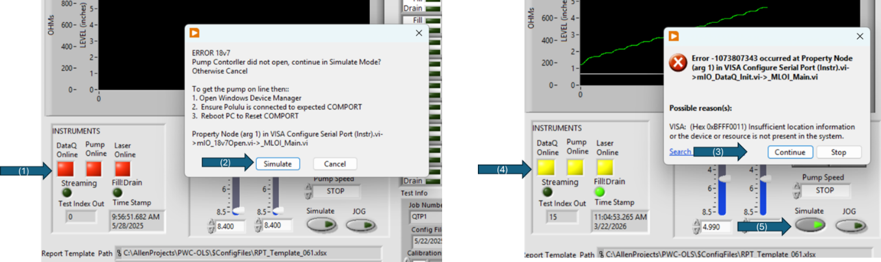

Tester __________________ Date ______________ PASS FAIL

- Shall provide a one-button means for starting the automated test.
NOTE: An automate start option has been added to the Settings as demonstrated above.
- Click on the MLOI Desktop icon.
- Start the MLOI Program, On the Test Information dialog Set:
Test | ProtPot |  | PreFill to | OFF
Replicate to | 1 |  | Auto Start to ON | OFF
 |  |  | Start in Jog to | OFF
- Verify the application is open and running and TEST State Out is in MANUAL mode.
- Click on the Run Test START button.
- Verify the Test protocol starts, the Run Test button is RUNNING and highlighted Green and TEST State Out is in START
- Verify after the Level (green plot) reaches EMPTY (bottom of plot), TEST State Out becomes Pre-Test Fill.
- Verify after a few seconds, the resistor ladder is plotted.
- Click on the Run Test button.
- Verify that Run Test button returns to gray START, the test protocol stops and the Test State Out indicates MANUAL mode.

Tester __________________ Date ______________ PASS FAIL

- Shall provide a means to manually control the Tank Level.
- Place the Simulate button to ON (green)
- Sete the JOG button to ON (green); the FILL and DRAIN buttons to OFF (gray) and select STOP in the Speed dropdown.
- Verify that the SP Slider has no control over PV
- Verify that the SP Slider and its digital output read approximately the same value over the slider range.
- Press the FILL Button
- Verify that the FILL button is ON (green) and the DRAIN button is OFF (gray)
- Verify the Speed becomes SLOW, and Level and PV values decrease towards FULL and the Green plot rises.
- Verify the Level value (above the plot) and the PV digital output read the same Level value.
- Verify that that PV slider and its digital output read approximately the same value over the slider range.
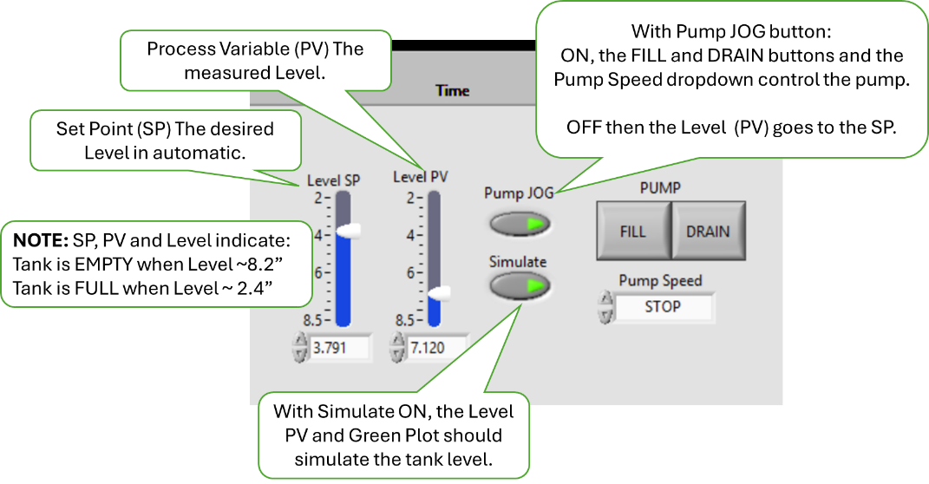
- In turn, set the Pump Speed to CREEP, SLOW, FAST.
- Verify that Level, PV and the green plot respond corresponding to the selected Speed. FAST is faster than SLOW which is faster than CREEP which is faster than STOP.
- Change the Pump Speed to Stop
- Verify the Level, PV and Plot stop changing.
- Verify that both FILL and DRAIN buttons are OFF (gray).
- Press the DRAIN button
- Verify that the FILL button is OFF (gray) and the DRAIN button is ON (green)
- Verify that PV slider and its digital output read approximately the same value over the slider range.
- Verify the Level value (above the plot) and the PV digital output read the same Level value.
- Verify that Level and PV values increases towards EMPTY and the Green plot falls.
- Change the Pump Speed to CREEP, SLOW, FAST.
- Verify that Level, PV and the green plot respond corresponding to the selected Speed. FAST is faster than SLOW which is faster than CREEP which is faster than STOP.
- Verify that both FILL and DRAIN buttons are OFF (gray).
- Alternate pushing FILL and DRAIN buttons
- Verify Speed goes to SLOW.
- Verify Speed can be changed in both FILL and DRAIN modes.
- Verify FILL and DRAIN can NOT be both ON (gray) at the same time.
- Set Pump JOG to OFF (gray). Set the SP slider to various Level Values.
- Verify the Level value, PV and Plot all drive toward the SP values and stop within 5% of the SP value.
- Ensure that the Laser and the Pump status lights are GREEN. Then Set the Simulate button to OFF (gray).
- Connect the instruments and USB hub, with SIM Mode OFF Repeat Steps 2 through 8
- Verify the actual tank performed the same as the simulated tank.

Tester __________________ Date ______________ PASS FAIL

- Shall display the current ChA and ChB measurement to 0.1Ω
- Shall display the level measurement to 0.001”
- Shall provide time-based plot of the resistance for both ChA and ChB, and tank Level..
- Verify Resistor and Level Measurement in SIM mode.
- Run MLOI. Start the MLOI Program, On the Test Information dialog Set:
Test | PostPot |  | PreFill to | OFF
Replicate to | 0 |  | Auto Start to ON | ON
 |  |  | Start in Jog to | OFF
- Click OK, Simulate and Continue.
- Set Level SP to a value between 2.4 and 8.5.
- Verify that stair step plot and that ChA and ChB values represent the charted Resistor Values (White and Red Plot) to one decimal place.
- Verify the Level values represent the charted Level values (Green Plot) to three decimal places.

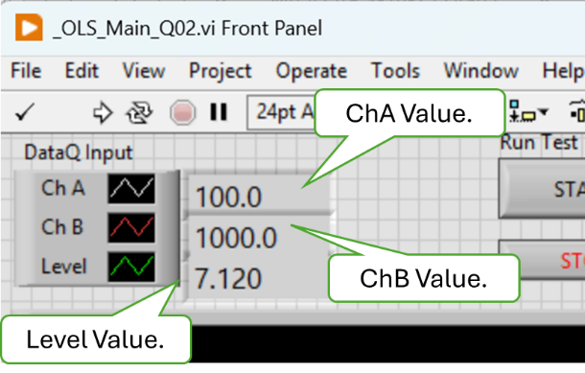

- Verify Resistor and Level Measurement in TEST mode. Connect the instruments and USB Hub.
- Run MLOI. On the Enter Test Information dialog, select PostPot, set the PreFill to OFF, Auto Start option to OFF, Start in JOG to OFF and Replicates to 0. Click OK, Simulate and Continue.
- With the MLOI app running, install the 100Ω test resistor.
- Verify that ChA Value and the white plot on the chart indicates about 100.0
- Verify that ChB Value and the red plot on the chart indicates about 100.0
- Verify that the Level reading is to three (3) decimal places and is displayed as green plot on the chart.

- Install the 1KΩ test resistor.
- Verify that ChA Value and the white plot on the chart indicates about 1000.0
- Verify that ChB Value and the red plot on the chart indicates about 1000.0
- Verify that the Level reading is to three (3) decimal places and is displayed as green plot on the chart.

Tester __________________ Date ______________ PASS FAIL

- Shall display the Pass/Fail status and progress of the test.
- Run MLOI. Start the MLOI Program, On the Test Information dialog Set:
Test | PostPot |  | PreFill to | OFF
Replicate to | 0 |  | Auto Start to ON | ON
 |  |  | Start in Jog to | OFF
- Click OK, Simulate and Continue.
- Verify the application is open and running and TEST State Out is in MANUAL mode.
- With the MLOI app running, Press the Run Test button to Running (green). Let the test progress.

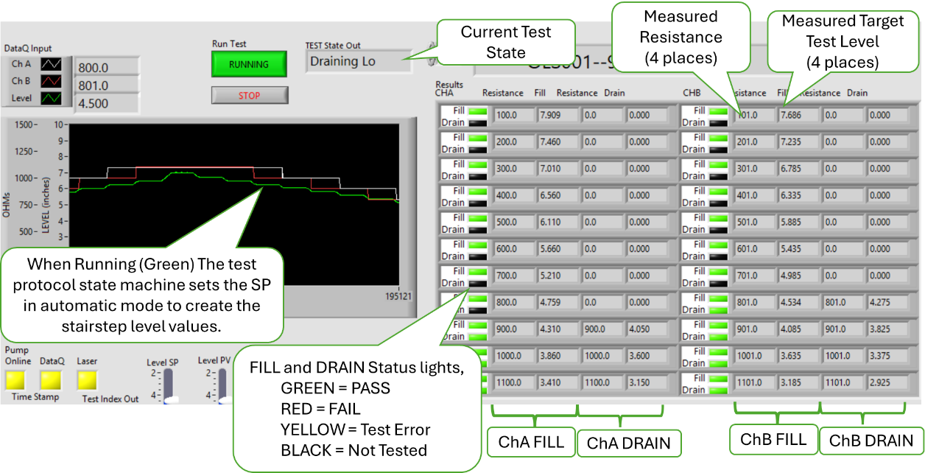

- Verify that Test State Out is sequencing through the test protocol.
- Verify the plots on the charts indicate the test protocol progress as stair step plots.
- Verify both the Fill and Drain status lights indicate test status as the test progresses.
- Verify the Resistor and Fill/Drain field are populated with the ChA, ChB and Level PV values as the test progresses.
- When the test is completed, (DONE state) at the prompt press SAVE button then exit the test.
- Verify that a report is generated and saved as an XL workbook and the app closes.

Tester __________________ Date ______________ PASS FAIL

- Shall provide a menu means to launch secondary methods.
NOTE sure what I meant? Perhaps the Calibrate menu, or read registry action all TBD.

- Shall not require operator to enter redundant information.
NOTE Accomplished in section 5.1.4 HMI.

Document management
- The test plan-> Configuration File shall be an XL workbook named to be traceable the test protocol implemented.
- The test plan-> Configuration File shall be version controlled in the Test repository per AAP QUAM.
- There shall be a means to add/include the test plan-> Configuration File path into the user prompt.
- Change a Test Configuration File used by the MLOI Test.
- Click on the dropdown then verify a choice of the default report folder path and “***Search***” is presented.
- Click on each of the file names and the “***Search***” verifying each it is selected indicated by a check mark and presented in the test box.
- Select “***Search***” Click on OK then verify the prompt to select a configuration file, then click OK then verify the File dialog opens.
- Select a configuration file then verify that <config file>.csv appears in the Test Configuration File test box. Press OK.
- CANCEL, STOP to Quit the MLOI Program.

- On the AAP network, navigate to the Configuration document in the form of an XL workbook (Config File) located in AAP Controlled Documents Vault located at M:\<Path to Controlled Documents Vault>.
- Verify that the Config File was approved by Engineering and Quality Assurance.
- Verify that the current version of the Config File is saved in the AAP Controlled Documents Vault located at M:\<Path to Controlled Documents Vault>.
- Verify the Config File name contains the common part number of the product associated with this test protocol configuration.
- With the app closed, click on the desktop icon
- If the Configuration File Path does not show the desired product test config file selected or not the path of the controlled document, then perform Steps 4 through 5.
- Click on Test Configuration to open the dropdown list of files.

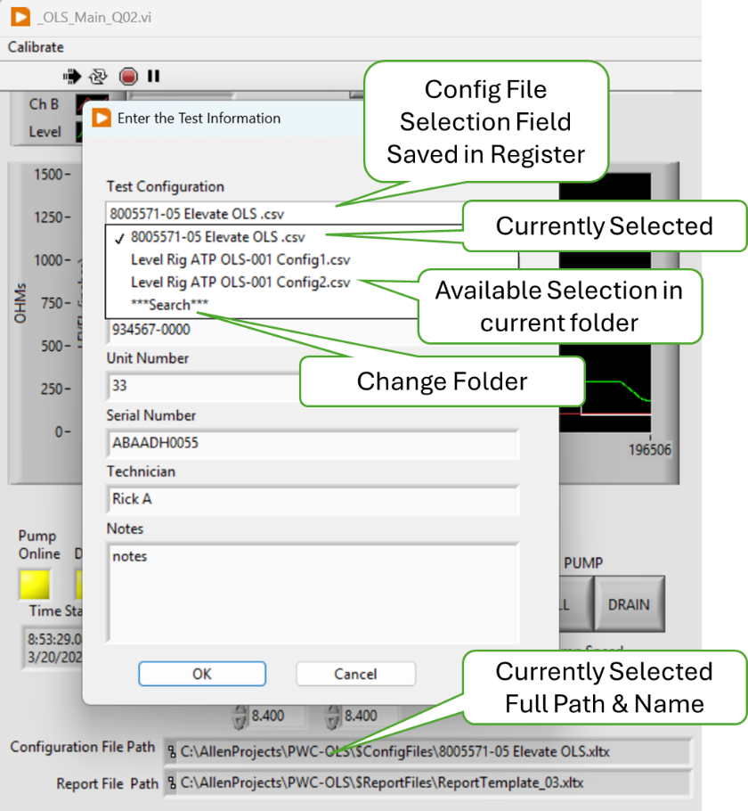

- Click on “**Search**” in the dropdown list to navigate to a new folder and open the selected Config file. Press OK.
- Verify the select path and file are displayed in the Configuration File Path indicator.
- Close and re-open the application
- Verify the path shown in the Configuration File Path indicator persists from one app activation to the next.
- Using the Test Configuration drop down change Config file from the list presented. Press OK.
- Verify the select path and file are displayed in the Configuration File Path indicator.
- Close and re-open the application
- Verify the path shown in the Configuration File Path indicator persists from one app activation to the next.

Tester __________________ Date ______________ PASS FAIL

Enter the test bench configuration parameters into XL test plan-> Configuration File.
- The test plan-> Configuration File shall contain the configurable test bench parameters as determined by the test bench design.
- Tabular data should be a copy and paste operation from the reference Test Document (ATP) into the XL test plan-> Configuration File document for loading as a LV parameter.
- The test plan-> Configuration File shall contain the referenced test protocol test bench parameters as determined by the test bench design.
- It should be a copy and paste operation to include the Test bench parameters into the XL test plan-> Configuration File document.
- The Test Plan shall contain a template of each test report generated on a separate sheet in the test plan XL workbook.
- The test plan-> Configuration File shall be capable of containing multiple templates to accommodate recording multiple test points or variations of test protocol.
- Find the Test Configuration File under test, by default …\$ConfigFiles
- Notice there are both a CSV and an XLSM file named by product ID for each Configuration. The CSV file is read and used by the MLOI program. The XLSM has should be used to modify the configuration parameters because it has explanatory tool tips on the field names.
- Once modification are made and the XLSM file is closed, a macro will run to copy the parameters from the XLSM file to the CVS file.
- Select and open an XLSM File then modify a parameter.
- NOTE: Cells in blue contain formulas and should not be changed.
- Click on the Cells in column A and verify an associated tool tip appears.
- Close the file, click YES to save changed then Click YES when prompted to overwrite the CSV file.

Tester __________________ Date ______________ PASS FAIL

Calibration Procedure
- There shall be a means to perform a 2-point linear calibration on each AI input.
- Run the Resistance Accuracy and Repeatability evaluation defined in Section 5.2.2.
- Resistance accuracy was successfully demonstrated during the Accuracy and Repeatability evaluation of Section 5.2.2.

Tester __________________ Date ______________ PASS FAIL

- There shall be a means to perform a 5-point linear calibration the Level Sensor.
- Run the Level Accuracy and Repeatability evaluation defined in Section 5.2.1.
- Level accuracy was successfully demonstrated during the Accuracy and Repeatability evaluation of Section 5.2.1.

Tester __________________ Date ______________ PASS FAIL

- These Bench calibrations shall be saved and linked to the Test Plan.
- On the Win11 LV workstation, navigate to C: \\<Root path of Application>\$Calibration folder. Open file “Cal Level RnR nnnn.xlsx”.
- Verify that both the level and resistance calibration raw values are recorded sequentially each time a calibration is run thus maintaining a calibration history.
- Verify the calibration parameters, slope (m) and offset (b) are calculated from the raw calibration data.
- Navigate to the M:\<AAP controlled doc vault>\$ConfigFiles and open the current <Config File>.xlsx.
- Verify that the calibration parameters (m or slope and b or offset) and calibration date are stored as the default for each active channel requiring calibration.
- Start the MLOI app. On the menu bar Select Calibration>Show all.
- Verify that the calibration parameters (m or slope and b or offset) and calibration date are stored in the registry each active channel requiring calibration.

Tester __________________ Date ______________ PASS FAIL

Troubleshooting Aids
- There shall be a means for manually setting the tank level.
NOTE Manual control of the pump was demonstrated in Test Case 13).
- Test Case 13) was successfully completed.
- If the Interface board has a Local/Remote and Fill/Drain switch, then these switches can be used to control the pump and the tank level. Set the Local/Remote switch to Remote and Fill/Drain switch to OFF.
- Verify the pump is OFF
- Set the Local/Remote switch to Remote and Fill/Drain switch to FILL
- Verify visually the tank level is rising. .
- Set the Local/Remote switch to Remote and Fill/Drain switch to DRAIN.
- Verify visually the tank level is Falling.

Tester __________________ Date ______________ PASS FAIL

- Each instrument (DataQ, Keyence) shall provide a health indicator.
NOTE: This requirement was evaluated by Test Case 4).
- Verify Test Case 4) was successful.

Tester __________________ Date ______________ PASS FAIL

- There shall be a simulated mode that provides simulated instrument input and Level response to be used with debugging.
NOTE: This requirement was evaluated by Test Case 18).
- Verify Test Case 18) was successful.

Tester __________________ Date ______________ PASS FAIL

- TBD There shall be a test vector mode that reads and processes AEPS type test data to validate the system processing algorithm.
NOTE, In the early development stage, I wrote an algorithm to read and AEPS data as an alternative input source, is this feature something we wish to keep in the final product?

Tester __________________ Date ______________ PASS FAIL

Use Case 3: Read Test Configuration -- Production Test User
- LV program must launch from PC desktop ICON in application running mode.
NOTE: This requirement was evaluated by Test Case 18).
- Verify Test Case 18) was successful.

Tester __________________ Date ______________ PASS FAIL

- TBD Maintenance User exclusive controls and Indicators shall be hidden in Test mode.
The maintenance and user controls have yet to be defined. We talked about having some or all fields on the Config File password protected. There are some routines like Measure tank response, and Instrument basic connectivity that are standalone LV VI’s.

Tester __________________ Date ______________ PASS FAIL

- All Test Parameters options must be presented in the form of a discrete choice (i.e. dropdown, pick list, radio button etc.).
- Path to valid XL test plans shall be saved in a non-volatile means and presented as a choice by Test name configured by the Maintenance User.
NOTE: Test parameters are encoded in the Config File. The tester is presented with a dropdown to select the Config File for the product being teste. Test Information such as Lot, serial number etc.
NOTE: This requirement was evaluated by Test Case 29).
- Verify Test Case 29) was successful.

Tester __________________ Date ______________ PASS FAIL

- The system shall be configured, initialized and shall report any NOT READY to test status: i.e. no functional instrument, out of calibration data, error reading test Plan etc.).
NOTE: Upon Test initialization, the tester is prompted to enter the Test information which includes selecting the appropriate Config File which contains all the test parameters. Test Case 20).
NOTE: The tester is prompted if a calibration activity is due. Test Cases 9) & 11).
NOTE: Instrument status is indicated on the status lights. Test Case 4)
- Verify Test Cases 4), 9), 11) and 20) are completed successfully.

Tester __________________ Date ______________ PASS FAIL

Load DUT identification information
- Engineering shall provide an ATP Test report template that provides the reference for the required DUT Test Information.
- Navigate to M: \\<AAP Controlled Doc Vault>\$Config File folder and open the current test Config File.
- Note the file name save in the Report File Template parameter.
- On the Win11 LV workstation, navigate to C: \\<Root path of Application>\$Reports folder and open the file named in step 2.
- Verify the ATP Card on sheet 1 (ATP) conforms to the ATP specified for the specific product.
- Verify the data and chart framework exists on sheet 2 (RAW DATA).
- Verify the data analysis framework exists on sheet 3 (Analysis).

Tester __________________ Date ______________ PASS FAIL

- There shall be a single dialog box to enter the required DUT test information.
NOTE: Upon Test initialization, the tester is prompted to enter the Test information which includes selecting the appropriate Config File which contains all the test parameters. Test Case 20).
- Verify Test Case 20) was successful.

Tester __________________ Date ______________ PASS FAIL

- The DUT information input shall be displayed and request conformation, in the form of an “are you sure?” type prompt with a YES, NO choice response. On NO reply, the user must be able to update that input which shall be retained but editable.
- Start the MLOI app. Enter the Test Information in the dialog, press OK>
- Verify data in the Test Info table matches the information entered in the dialog box.
- Verify the test is paused and the tester is prompted “Ready to Start?’
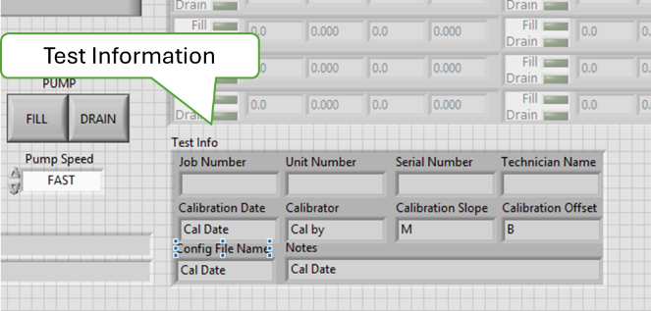

Tester __________________ Date ______________ PASS FAIL

Load DUT into the test bench.
- On YES reply, the system shall perform a continuity check to indicate ready to test if continuity is detected otherwise indicate not ready for test.
- Verify the hardware drawings, including block diagram, schematic, assembly drawing and Gerber files are released.
- All hardware files are in the release folder at <Path file>

Tester __________________ Date ______________ PASS FAIL

- The test status indicator may provide a tool tip as to the not ready issue.
- Verify the hardware drawings, including block diagram, schematic, assembly drawing and Gerber files are released.
- All hardware files are in the release folder at <Path file>

Tester __________________ Date ______________ PASS FAIL

Use Case 5: Run DUT Test -- Production Test User
- The Test protocol shall implement the ACCEPTANCE TEST PROCEDURE FOR ALLEN 8005571.05, Report# 200333. (attached)
- Verify the hardware drawings, including block diagram, schematic, assembly drawing and Gerber files are released.
- All hardware files are in the release folder at <Path file>

Tester __________________ Date ______________ PASS FAIL

- The oil level shall be cycled from empty to full to empty prior to testing.
- Verify the hardware drawings, including block diagram, schematic, assembly drawing and Gerber files are released.
- All hardware files are in the release folder at <Path file>

Tester __________________ Date ______________ PASS FAIL

- The oil level shall be filled from empty to the Target Test Point.
- Verify the hardware drawings, including block diagram, schematic, assembly drawing and Gerber files are released.
- All hardware files are in the release folder at <Path file>

Tester __________________ Date ______________ PASS FAIL

- The Resistance shall be measured after any level variations subside to the specified criteria.
- Verify the hardware drawings, including block diagram, schematic, assembly drawing and Gerber files are released.
- All hardware files are in the release folder at <Path file>

Tester __________________ Date ______________ PASS FAIL

- If the measured resistance is within the specified tolerance, the test at this level is PASS, else a FAIL Shall be logged.
- Verify the hardware drawings, including block diagram, schematic, assembly drawing and Gerber files are released.
- All hardware files are in the release folder at <Path file>

Tester __________________ Date ______________ PASS FAIL

- The above three steps are repeated for each Low Fill Limit alternating between measuring ChA and ChB.
- Verify the hardware drawings, including block diagram, schematic, assembly drawing and Gerber files are released.
- All hardware files are in the release folder at <Path file>

Tester __________________ Date ______________ PASS FAIL

- The oil level shall be drained from full to the Target Test Point.
- Verify the hardware drawings, including block diagram, schematic, assembly drawing and Gerber files are released.
- All hardware files are in the release folder at <Path file>

Tester __________________ Date ______________ PASS FAIL

- The Resistance shall be measured after any level variations subside to the specified criteria.
- Verify the hardware drawings, including block diagram, schematic, assembly drawing and Gerber files are released.
- All hardware files are in the release folder at <Path file>

Tester __________________ Date ______________ PASS FAIL

- If the measured resistance is within the specified tolerance, the test at this level is PASS, else a FAIL Shall be logged.
- Verify the hardware drawings, including block diagram, schematic, assembly drawing and Gerber files are released.
- All hardware files are in the release folder at <Path file>

Tester __________________ Date ______________ PASS FAIL

- The above Three steps are repeated for each High Drain Limit, alternating between measuring ChA and ChB.
- Verify the hardware drawings, including block diagram, schematic, assembly drawing and Gerber files are released.
- All hardware files are in the release folder at <Path file>

Tester __________________ Date ______________ PASS FAIL

- The DUT shall be recorded as PASS if no FAILs are recorded.
- Verify the hardware drawings, including block diagram, schematic, assembly drawing and Gerber files are released.
- All hardware files are in the release folder at <Path file>

Tester __________________ Date ______________ PASS FAIL

- The test status shall graphically display Ch A & Ch B resistance in ohms and display the Level in inches.
- Verify the hardware drawings, including block diagram, schematic, assembly drawing and Gerber files are released.
- All hardware files are in the release folder at <Path file>

Tester __________________ Date ______________ PASS FAIL

- All three traces shall be scaled so they are presented overlayed at a similar size. The Chart scale is a configurable test parameter.
- Verify the hardware drawings, including block diagram, schematic, assembly drawing and Gerber files are released.
- All hardware files are in the release folder at <Path file>

Tester __________________ Date ______________ PASS FAIL

- A display shall indicate each Switch status as NOT TESTED (gray), PASS (green) or FAIL (red) or ERROR (yellow) for a detected procedural problem.
- Verify the hardware drawings, including block diagram, schematic, assembly drawing and Gerber files are released.
- All hardware files are in the release folder at <Path file>

Tester __________________ Date ______________ PASS FAIL

- A display shall indicate the measured Target Test Point and the actual resistance measured there.
- Verify the hardware drawings, including block diagram, schematic, assembly drawing and Gerber files are released.
- All hardware files are in the release folder at <Path file>

Tester __________________ Date ______________ PASS FAIL

- The User must have the means to monitor the Test bench health during testing.
- Verify the hardware drawings, including block diagram, schematic, assembly drawing and Gerber files are released.
- All hardware files are in the release folder at <Path file>

Tester __________________ Date ______________ PASS FAIL

- Users must have a means to PAUSE the test.
- Verify the hardware drawings, including block diagram, schematic, assembly drawing and Gerber files are released.
- All hardware files are in the release folder at <Path file>

Tester __________________ Date ______________ PASS FAIL

- Users must have a means to ABORT the test.
- Verify the hardware drawings, including block diagram, schematic, assembly drawing and Gerber files are released.
- All hardware files are in the release folder at <Path file>

Tester __________________ Date ______________ PASS FAIL

- Users must have the option to RERUN the test.
- Verify the hardware drawings, including block diagram, schematic, assembly drawing and Gerber files are released.
- All hardware files are in the release folder at <Path file>

Tester __________________ Date ______________ PASS FAIL

- Users must have the option to run the level in manual or automatic modes.
- Verify the hardware drawings, including block diagram, schematic, assembly drawing and Gerber files are released.
- All hardware files are in the release folder at <Path file>

Tester __________________ Date ______________ PASS FAIL

- The default test mode is automatic.
- Verify the hardware drawings, including block diagram, schematic, assembly drawing and Gerber files are released.
- All hardware files are in the release folder at <Path file>

Tester __________________ Date ______________ PASS FAIL

Use Case 5: Generate DUT Test Report -- Production Test User
- The Test results and the Product information for each test shall be saved in one XL workbook at the option of the operator.
- Verify the hardware drawings, including block diagram, schematic, assembly drawing and Gerber files are released.
- All hardware files are in the release folder at <Path file>

Tester __________________ Date ______________ PASS FAIL

- The ATP Test Report shall be on one sheet labeled “ATP Report” as specified in the Report Template supplied by Engineering.
- Verify the hardware drawings, including block diagram, schematic, assembly drawing and Gerber files are released.
- All hardware files are in the release folder at <Path file>

Tester __________________ Date ______________ PASS FAIL

- The time in 50ms intervals, ChA and ChB resistance in ohms and Level in inches shall be recorded and plotted on a sheet labeled “Raw Data.”
- Verify the hardware drawings, including block diagram, schematic, assembly drawing and Gerber files are released.
- All hardware files are in the release folder at <Path file>

Tester __________________ Date ______________ PASS FAIL

- The third sheet shall be labeled “Analysis” and include the actual level at which the Switch Point occurred (L_{SWP} refer to figure 2).
- Verify the hardware drawings, including block diagram, schematic, assembly drawing and Gerber files are released.
- All hardware files are in the release folder at <Path file>

Tester __________________ Date ______________ PASS FAIL

- The sheet labeled “Analysis” shall include identification of “double actuations” (definition TBD) and slow “rise time” (definition TBD).
- Verify the hardware drawings, including block diagram, schematic, assembly drawing and Gerber files are released.
- All hardware files are in the release folder at <Path file>

Tester __________________ Date ______________ PASS FAIL

- The values on the Analysis sheet may be calculated post-test execution.
- Verify the hardware drawings, including block diagram, schematic, assembly drawing and Gerber files are released.
- All hardware files are in the release folder at <Path file>

Tester __________________ Date ______________ PASS FAIL

  - Non - Functional Requirements Test Procedures

Annual Level Calibration Type 1 Gage and Capability Study

The purpose of Annual Level Calibration is to determine the Slope and Offset calibration coefficients that scale the laser reading to correspond to the gage level measurement as shown in Type 1 Gage Study. The Level calibration procedure selects levels at the five quartile boundaries with +/- 0.100” random offset that the calibrator sets using the digital height gage, then the program records laser reading. A linear regression is performed on these 5 points to determine the calibration coefficients which along with the raw data are recorded in the $Calibration.xlxs workbook.

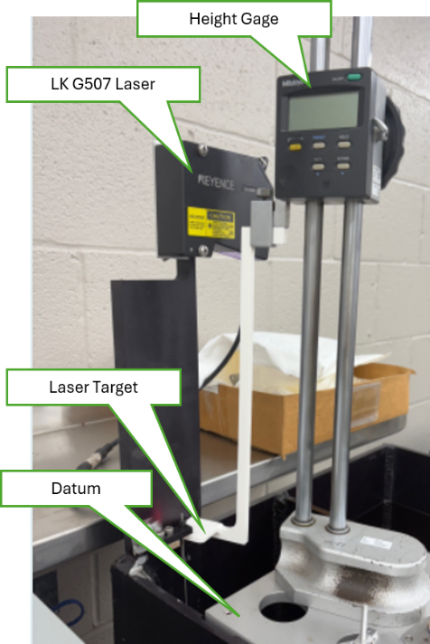
Procedure
- Tare (zero) the height gage (± 0.001”) to Datum
- Start a 5-point level calibration $MLOI_LevelCalibration.vi
- Set the target to the exact level for each test point.
- Press Save to record the laser reading at that point.
- Repeat trial run for each of 5 level Test Points,
- Record slope and intercept for this calibration
- Repeat calibration 5 times.
 | Coefficients | Lower 95% | Upper 95%
Intercept | 9.190 | 9.188 | 9.192
Laser | -0.997 | -0.999 | -0.995
- Calculate Confidence Limits for Slope and Intercept for 5 calibrations and save the coefficients in the Configuration File.

Level Capability
Tolerance = 0.100” (± 0.050”)
Study Variation (SV) = 6σ
SV = 6 * 0.0017= 0.0102
C_{g} = .2 * Tolerance / SV
C_{g} = 0.02/ 0.0102
C_{g} = 1.96 Greater than 1.33
so must accept Level SANS FLOAT
IS CAPABLE

Tester __________________ Date ______________ PASS FAIL
Daily Level Zero Correction Check

Daily (first time run each day) Zero check uses a gage block to determine the offset correction that is applied to the calibration. The laser span and linearity are considered stable and only require an annual calibration check. However the addition of the float introduces the potential for some variance in the offset. For this reason, it is deemed necessary to check the level zero prior to the use of MLOI each day.

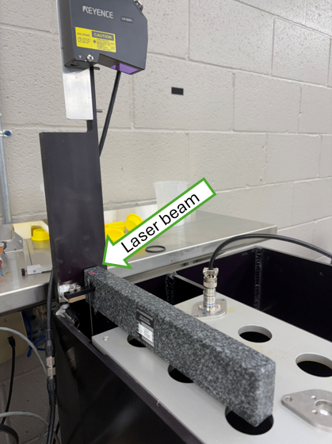
Procedure

    - Upon starting MLOI for the first time of the day, the user is prompted to Zero the Laser Measurement once the laser is online.

    - The user is prompted to place the 2.000” gage block on the datum reference plane.

    - Ensure that the gage block is flat across the top plate and the red laser beam is shining on the gage block.

    - Normally the operator would Save the new Level Zero at this point or contact Test Engineer if the New and Old Zero’s are significantly different.

Tester __________________ Date ______________ PASS FAIL

Resistance Calibration Repeatability & Accuracy

The purpose of Resistor Calibration is to determine the Slope and Offset calibration coefficients that scale the DataQ reading, 14.7ma current source, and buffer circuit to present the measured resistance at the nominal reference current. The Resistance calibration procedure uses two reference resistors with known values of 100.0Ω and 1000.0Ω.. A linear regression is performed on these 2 point to determine the calibration coefficients which are recorded in the $Calibration.xlxs

Procedure
- Start a 2-point resistor calibration $MLOI_ResistorCalibration.vi
- Follow the prompts to measure the resistance references if necessary
- Insert the 100Ω Reference as the front panel DUT. Click OK to record the Resistance.
- Insert the 1KΩ Reference as the front panel DUT. Click OK to record the Resistance.
- The data and the calibration coefficients are recorded on Elevate Resistance sheet of $Calibration workbook. Record the coefficients in the $ConfigFile.

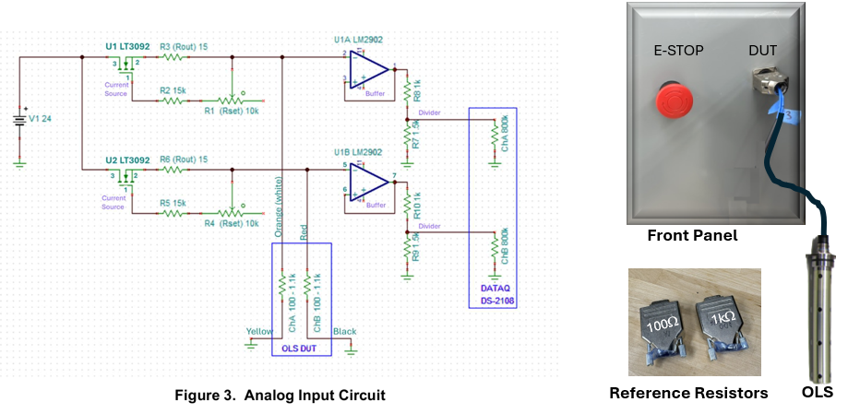
RESULTS:
Channel | Slope | Intercept
Ch A | 116.631 | -0.729
Ch B | 116.622 | -0.721

Double check this table
Resistor Capability
Tolerance = 2.0Ω (± 1.0Ω)
Study Variation (SV) = 6σ
SV = 6 * 0.0017= 0.0102
C_{g} = .2 * Tolerance / SV
C_{g} = 2,0/ 0.78
C_{g} = 2.56 Greater than 1.33
so must accept Level SANS FLOAT
IS CAPABLE

Measurement Gage R & R
Stability and Drift
Tank Response and Fill Rate

- Hardware Installation

- Instrument Initialization

- LabVIEW Application Installation
The LabVIEW application is run in a LabVIEW Runtime environment that must be loaded on the target workstation. And each of the instrument driver must be loaded per Appendix II. The LabVIEW app is version controlled in GitHub Allen Aircraft account in the internet cloud and should be downloaded from there.
- Have the IT department load the LabVIEW Runtime on the target workstation.
- Contact AAP IT department for GitHub login credentials.
- Open an internet browser and navigate to https://github.com/AllenAircraft/PWC-OLS/tree/main.
- On the Code page, from the top left button, select the code revision to be evaluated. Note that the Main branch is always the latest release
.
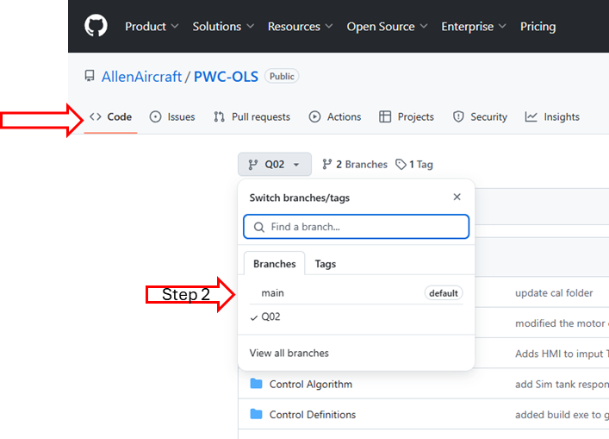

NOTE: The build folder containing MLOI_Elevate executable can be loaded as a stand alone from the ZIP file (Step 5) or with the Development system (Step 6).
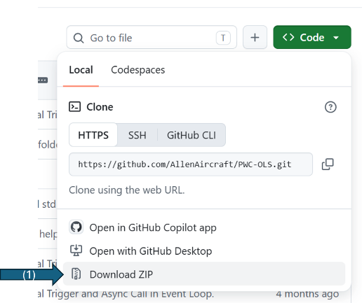
- To Load only Load the executable files:
- Click on Code button then select Download ZIP on the dropdown.
- Open the downloaded ZIP file and navigate the builds Folder.
- Extract the Build folder to the Target System.
- On the Target system navigate to ..\builds\MLOI_Elevate
- Create/Copy the $ConfigFile and $ReportFiles to the target system as necessary.
- To run the MLOI App, click MLOI_Elevate.exe
- To Copy the Development program to your development system:
- Navigate to a folder that will contain the working development project folder:
- Right click to open the popup and select Open in Terminal
- On the Github page, click on green Code button and select and copy (^C) https://github.com/AllenAircraft/PWC-OLS.git Cloning using the web URL.
- At the prompt in the Terminal type:
>git clone https://github.com/AllenAircraft/PWC-OLS.git
- Verify that MLOI development project folder is extracted to “PWC-OLS” on your development system.
- Open the new PWC-OLS folder on the target system and click on _MLOI_Main.vi to run the development version of the program.
- To run the Production Application, it is convenient to make a shortcut to ..\MLOI-Elevate\_MLOI_Main.exe and place that shortcut on the target desktop.
NOTE: Paths to the Configuration File is saved on the Target system registry that must be initialized the first time MLOI is run or if the Configuration file is moved.

FROM Previous Version

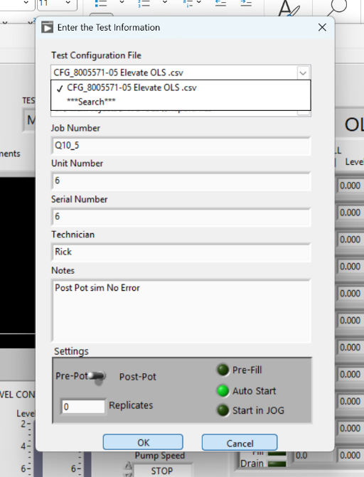
- Ensure that the proper version of the Configuration and Report Template files are saved per AS9100 Quality controlled documents policy. Note the path to the Configuration files.
- Run the MLOI on the click on the Maintenance menu, input the requested code. Click on the Configuration File Dropdown and select **Search.
- Navigate to the Configuration File Path noted in Step 9 and select a test file. By selecting this test file, the path to all associated configuration files is saved in the MLOI registry.
- Click OK, then exit the program to update the saved configuration file path.
- Ensure that the current report template file is saved in the Configuration File Path noted in Step 9.

- Evaluate Test Report Save Folder drop down.
- Click on the dropdown then verify a selection of <config>.csv files and “search” are presented.
- Click on one of the <config>.csv then verify that file is selected indicated by a check mark and presented in the test box.
- Click on one of the “***Search***” then verify it is selected indicated by a check mark and presented in the test box.
- Click on OK then verify the prompt to select a report destination folder, then click OK then verify the Folder dialog opens.
- Select a destination Folder then verify that path appears in the Test Report Save Folder test box.
- CANCEL, STOP to Quit the MLOI Program
- On the Test Information dialog, make the selection shown below, Click OK, then verify the results indicated to the Right.
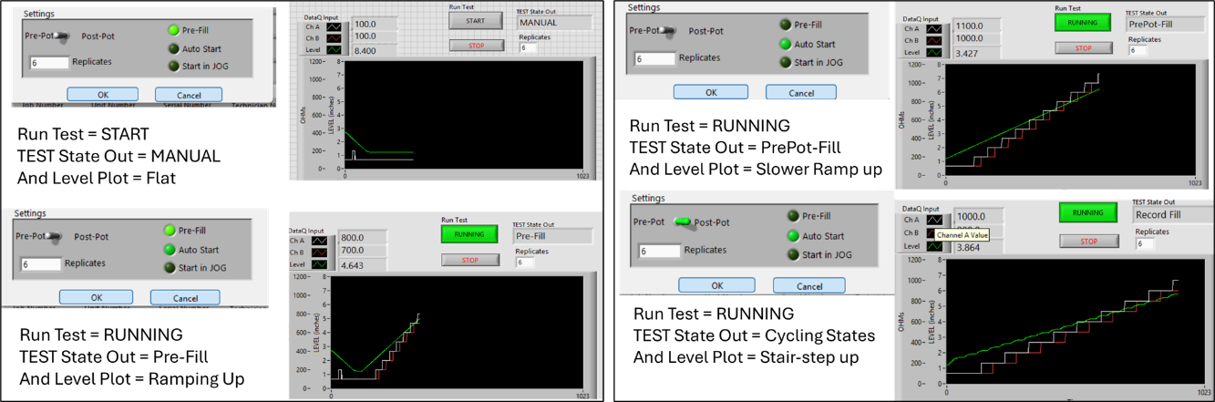
- Press STOP, No Quit to exit MLOI Program after each observation. Repeat for each setting shown.
- Evaluate Replicate Setting.
- Start the MLOI Program, On the Test Information dialog Set:
Test | PrePot |  | PreFill to | OFF
Replicate to | 1 |  | Auto Start to ON | ON
 |  |  | Start in Jog to | OFF
- Pess OK, Let the test run to completion Note the Test Name.
- Verify the PrePot test executed two times.
- Navigate to the Report folder indicated in the Report Folder Path indicator in the lower left corner. Verify two test reports were generated with file name: <Test Name> <YYMMDDHHMM formatted timestamp>.xlsx
- Restart the MLOI Program and Verify that Replicate value tered above persists.
- Evaluate Replicate Setting.
- Start the MLOI Program, On the Test Information dialog Set:
Test | PrePot |  | PreFill to | OFF
Replicate to | 1 |  | Auto Start to ON | ON
 |  |  | Start in Jog to | OFF
- Pess OK, Let the test run to completion Note the Test Name.
- Verify the PrePot test executed two times.
- Navigate to the Report folder indicated in the Report Folder Path indicator in the lower left corner. Verify two test reports were generated with file name: <Test Name> <YYMMDDHHMM formatted timestamp>.xlsx
- Restart the MLOI Program and Verify that Replicate value tered above persists.

